**LINQ –Day1 Assignments**

**Using Console Application:**

1. Declare a List of numbers as shown :

List<int> numbers = new List<int>() { 2,4,6,7,1,4,2,9,1};

Then write the following queries

**Query1**: Display numbers without any repeated Data and sorted

o/p should be as follow:

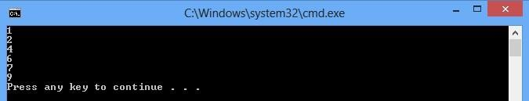

**Query2**: using **Query1** result and show each number and it’s multiplication

o/p should be as follow:

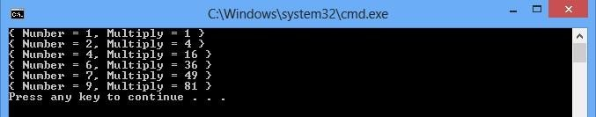

1. declare an array of names as shown :

# string[] names = { "Tom", "Dick", "Harry", "MARY", "Jay" };

Then write the following queries:

**Query1**: Select names with length equal 3.

o/p should be as follow:

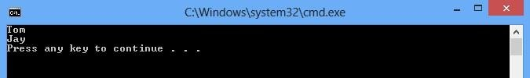

**Query2**: Select names that contains “a” letter (Capital or Small )then sort them by length

o/p should be as follow:

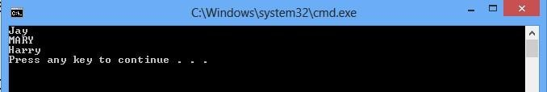

**Query3:** Display the first 2 names

o/p should be as follow:



3- Declare a class Subject that contains the following properties (Code, Name) and declare Student class that contains the following properties (ID, FirstName, LastName , Subject []), then define List of students As follow

List<Student> students=new List<Student> (){ new Student(){ ID=1, FirstName="Ali", LastName="Mohammed",

subjects=new Subjcet[]{ new Subjcet(){ Code=22,Name="EF"}, new Subjcet(){ Code=33,Name="UML"}}}, new Student(){ ID=2, FirstName="Mona", LastName="Gala",

subjects=new Subject []{ new Subject(){ Code=22,Name="EF"}, new Subject (){ Code=34,Name="XML"},new Subject (){ Code=25, Name="JS"}}}, new

Student(){ ID=3, FirstName="Yara", LastName="Yousf", subjects=new Subject

[]{ new Subject (){ Code=22,Name="EF"}, new Subject (){ Code=25,Name="JS"}}}, new Student(){ ID=1, FirstName="Ali", LastName="Ali",

subjects=new Subject []{ new Subject (){ Code=33,Name="UML"}}},

};

Then write the following queries

**Query1**: Display Full name and number of subjects for each student as follow

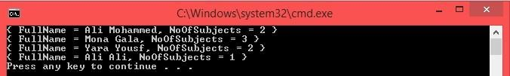

**Query2**: Write a query which orders the elements in the list by FirstName **Descending** then by LastName **Ascending** and result of query displays only first names and last names for the elements in list as follow

